MARS ROVER MANIPAL - RESEARCH
TASK PHASE
WINTER PROJECT, 2019 -20
TITLE – GENERATION OF NEW POKEMONS USING Generative Adversarial Networks
DL Framework Used: PyTorch

- Introduction
Generative adversarial networks (GANs), are a framework for training a Deep Learning model to use the training data’s distribution to generate new data from the same distribution.

GANs were invented by Ian Goodfellow in 2014 and described in his paper Generative Adversarial Nets.

In short, GANs are made of two different models, one being the Generator and the other being the discriminator. The job of generator is to generate fake images that some what look like the real data in the beginning. The job of the discriminator is to look at an image and output whether or not it came from the real images.

During training the generator is constantly trying to outsmart the discriminator by generating images that are really close to the training images, while discriminator is acting like a counterfeit to discard images and become more better in classification.

By the end the goal is to generate fake images that look as if they came from those datasets.

- Work done
Here I’ve used pokemon dataset from Kaggle which has approximately 20000 images of labelled pokemons. For training I’ve used Google’s
Colaboratry cloud GPU.

The specific type of GAN used in this project is the Deep Convolutional Generative Adversarial Network (DCGAN) mentioned in the paper DCGANs — Radford et al. (2015)
The discriminator is designed with strided conv. layers, batch normalization layers, and LeakyReLU activations. The input is a 3 by 64 by 64 input image and the output is a scalar probability that the input is from the real data distribution.

The generator is comprised of conv-transpose layers, batch normalized layers, and ReLU activations.

The input is a latent vector, z, that is drawn from a standard normal distribution and the output is a 3 by 64 by 64 RGB image. The strided conv-transpose layers allow the latent vector to be transformed into a volume with the same shape as an image.

The architecture for the model is inspired from the original DCGAN paper.

Time Specs: Every time I trained my model it took around 4-5 hours for 50 epochs.

- Experiment and Hyperparameter Tuning
Experiment has been performed more than 2 times with specific result generated in only the below three.

Coming to the details of hyperparameters I chose.
- No. of epochs – 10, learning rate = 0.0005 which decreases by 10% every 2 epochs without changing the architecture of both generator and discriminator.
- No. of epochs – 50, learning rate = 0.0005 which decreases by 10% every 5 epochs with a minor change in the activation function instead of using ReLU I used LeakyReLU which had the good result according to me.
- No. of epochs – 50, learning rate = 0.0005 which decreases by 10% every 5 epochs with a minor change in the activation function instead of using ReLU I used SELU which had the worst result according to me. The reasons for worst results were mode collapse.
The code starts with importing all the essential torch libraries and defining the hyperparameters.
Dataset is loaded using dataloader and device to run is set finally it is plotted using matplotlib.
Next on our way is Weight Initialization
From the DCGAN paper, the authors specify that all model weights shall be randomly initialized from a Normal distribution with mean=0, stdev=0.02.
The weight_init function reassigns these weights to all the layers.
Generator
This network is designed to map the latent vector (z) to data-space. Since we are dealing with images, this noise is converted to an RGB image with same size as that of the training images.
We do this through series of conv-transpose layers which are strided and each paired with a batch norm layer and a ReLU activation / LeakyReLU. The output is squeezed by tanh function.
Discriminator
This network performs classification of real and fake images and outputs a scalar probability. Now we have conv2D layer,LeakyReLU and Batch norm layers for the network. The probability is obtained from the last applied sigmoid function.
Loss Functions and Optimizer.
We use Binary Cross Entropy loss as our loss function.
We define our real label as 1 and the fake label as 0. These labels will be used when calculating the losses of D and G, and this is also the convention used in the original GAN paper. Finally, we set up two separate optimizer, one for D and one for G. As specified in the DCGAN paper, both are Adam optimizer with learning rate 0.0005 and Beta1 = 0.5.

Training
Discriminator.
We train it by separating it to first supplying real data , forward pass calculating log(D(x)) and then supply fakes to calculate log(1-D(G(z))) then accumulate gradients through back-propagation.
Now we call discriminator’s optimizer.
Generator.
As stated in the original paper, We train the generator by minimizing log(1-D(G(z)) so that it generates better fakes. We do this by maximizing log(D(G(z))) accordingly.
Then we plot the Generated images and loss vs iteration graphs.
Atlast we compare the generated images with real ones.
- Results
Here I paste the screenshots of the results generated during all the generated images

1. with 10 epochs

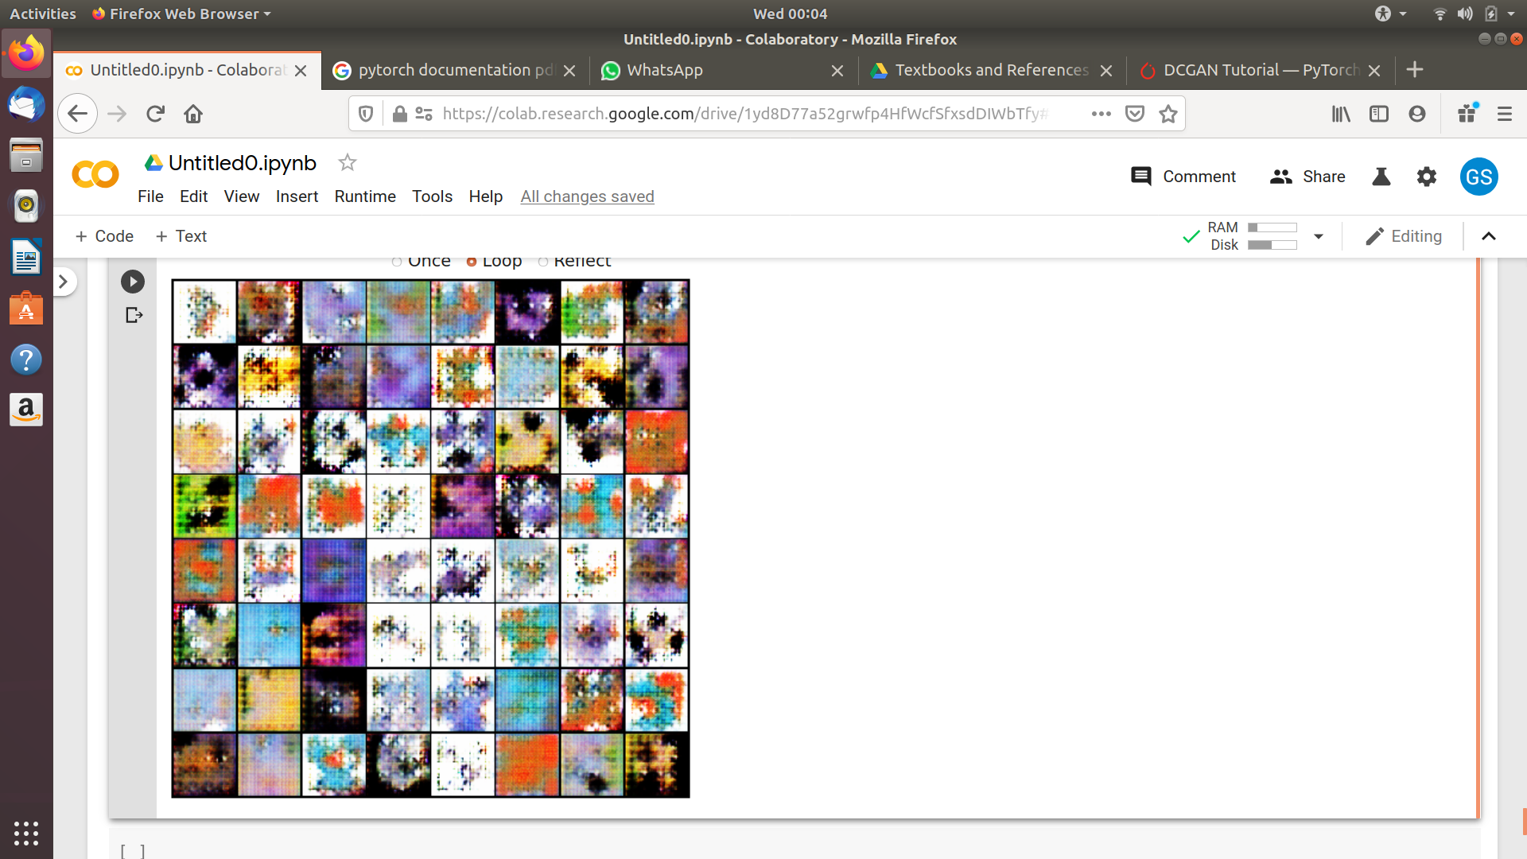
2. with 50 epochs using LeakyRelu instead of ReLU in Generator

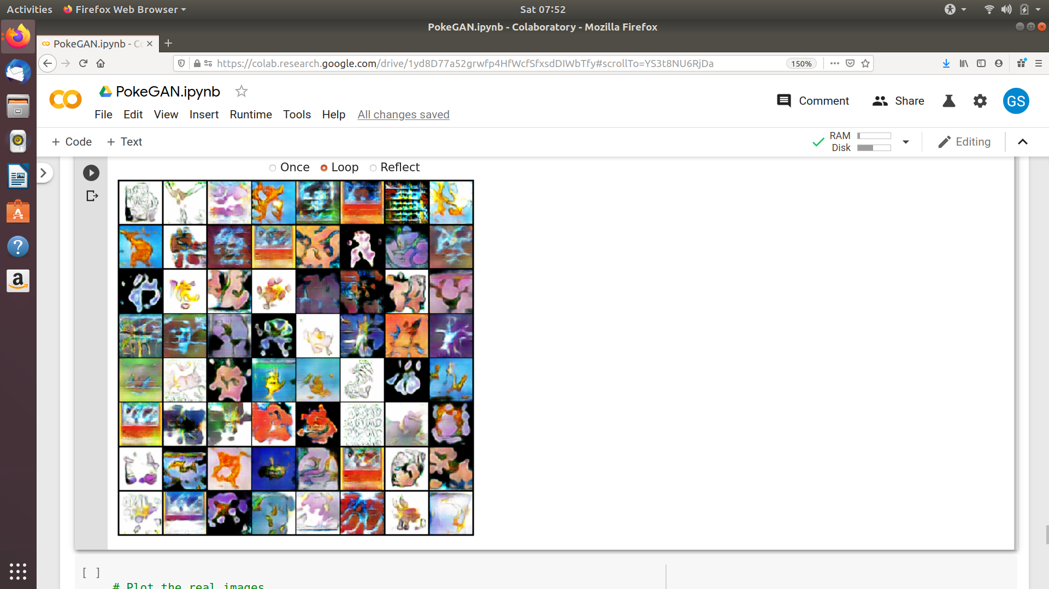

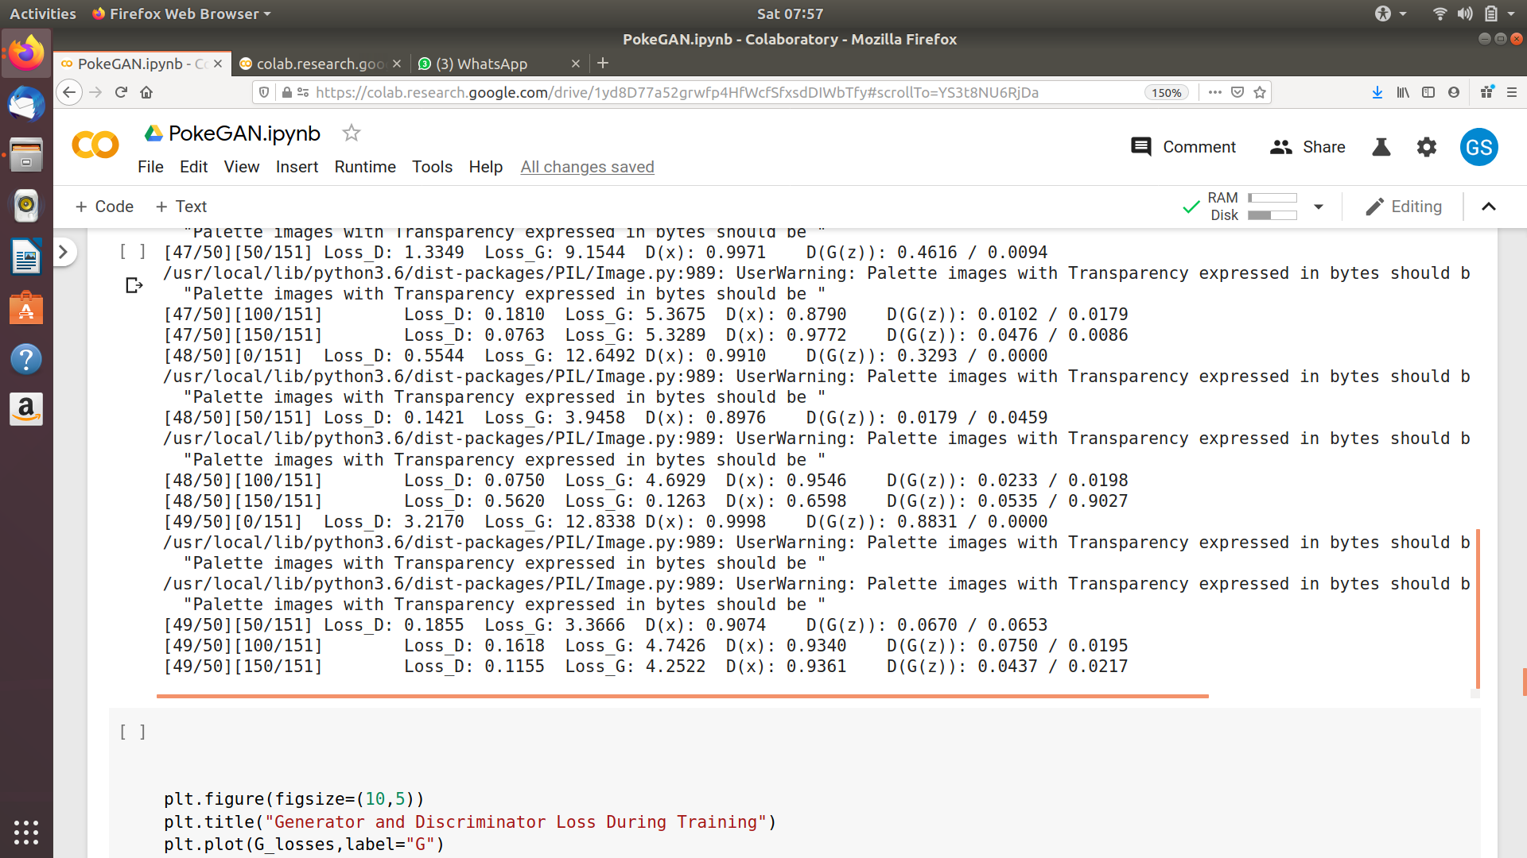

3. with 50 epochs using SELU activation function in Generator.
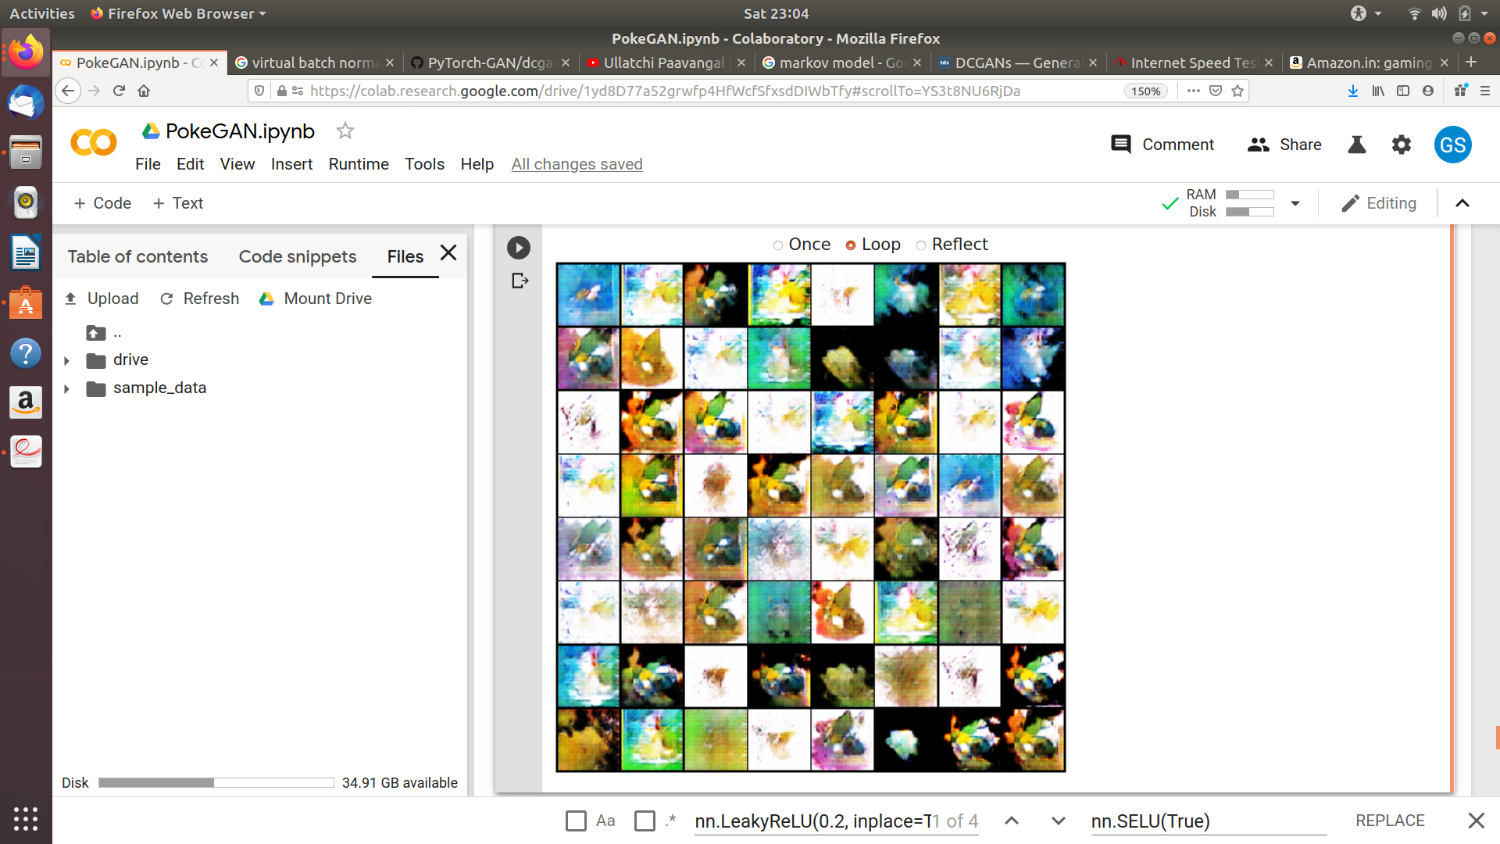

References.
1. Ian Goodfellow 2014 GAN paper and Redford et al. DCGAN Paper.
2. DCGAN tutorial from PyTorch documentation.
3. Towards Data Science page on GAN

